|  |  |  |  |  |  |
| --- | --- | --- | --- | --- | --- |
| **Course Code** | | **MEE427 PID Control** | | | |
| **Lab Work:** | | **Extraction of Motor Model with System Identification Procedure using Data Acquisition (DAQ) Instrument and Implementation of PID Control to DC Motor** | | | |
| **Related Learning Outcome** | | **1,4** | | | |
| **Student ID** | **Student Name** | | **Student Surname** | | **Student Signature** |
|  |  | |  | |  |
| **Grading Policy** | | | | | |
| Circuits (20%)  Circuits built for Lab works | | Progressing Lab Works (50%)  Progressing reports during semester | | Final Demo (30%)  Final demonstration with built overall system | |

Required equipment for system identification procedure:

1. Computer (LabView and necessary drivers should be installed before)
2. Data acquisition device (will be given in the laboratory)
3. DC Motor (will be given in the laboratory)
4. DC Motor Driver (will be given in the laboratory)
5. Power Supply (will be given in the laboratory)
6. Potentiometer (will be given in the laboratory)
7. Necessary connection cables (bunch of different types of jumper cables)

***PLEASE FOLLOW THE STEPS GIVEN BELOW***

The purpose of this work is to collect position data of a DC motor with given input voltage by using a potentiometer as a feedback device. Extracted input-output relation is used in revealing the motor model by using the system identification procedures.

A simple way to collect the required data is using LabView program and a DAQ device which is compatible with LabView. NI MyDAQ and NI USB-6009 data acquisition devices are compatible with LabView program (NI: National Instruments). These devices have Analog and Digital inputs/outputs, providing an easy connection to computer via USB cable.

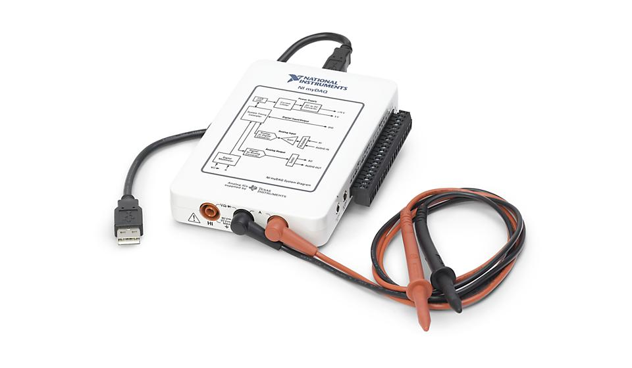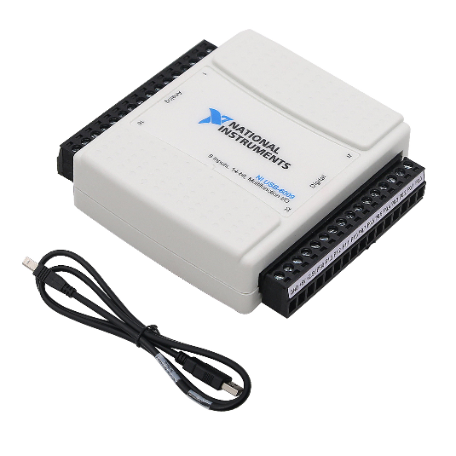

Figure: NI MyDAQ Student and NI USB-6009 portable DAQ devices

The related quick start documents with the mentioned software and hardware are given below:

* <https://learn.ni.com/learn/article/labview-tutorial>
* <https://www.ni.com/en-tr/shop/hardware/products/mydaq-student-data-acquisition-device.html>
* <http://www.csun.edu/~rd436460/Labview/USB%206008%20Users%20Guide.pdf>

The software part should follow the steps in order:

1. Installing LabView
2. Installing NI-DAQmx (includes DAQ device drivers and LabView integration)

**NOTE: 1) It is very critical to use compatible software versions.**

**2) Installing LabView program as 1st step is a must.**

1. ***Installing LabView***

**NOTE:** It requires an account to run LabView. If an account does not exist, sign up and create an account.

Download and install LabView from its official website. The version should be supported by your OS (for Windows 11 2025 Q1) and the edition should be “Community” version (free version). The version number is decided through hardware compatibility chart. A verification screenshot from the install website is given below.

<https://www.ni.com/en/support/downloads/software-products/download.labview.html#559067>

Operations of NI-based programs (LabView and NI DAQ devices are included) like installation, update, remove, etc. are carried out using “NI Package Manager”. However, it is not recommended for this application due to software-hardware compatibility, the latest versions are not compatible with each other at this moment.

A brief LabView tutorial may be followed using quick start guide whose website link was given before.

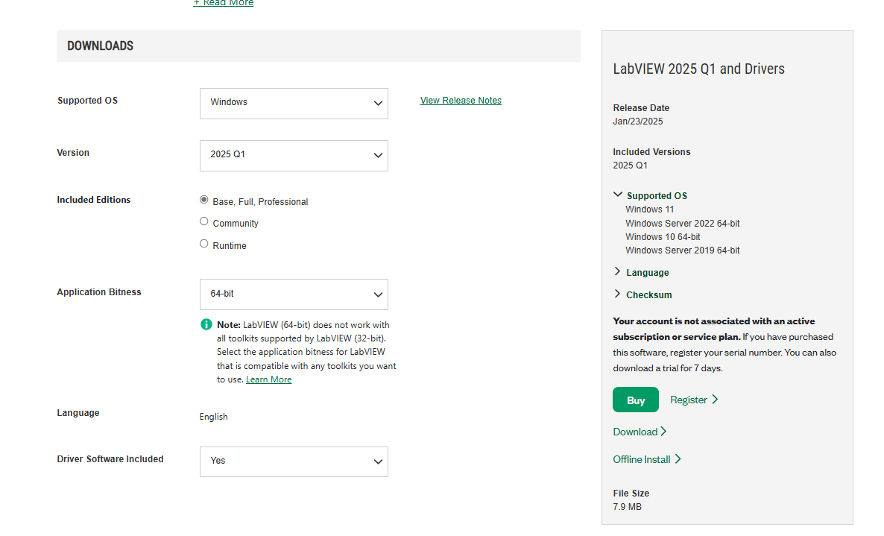

1. ***Installing NI-DAQmx***

Download and install NI-DAQmx from its website. The version should be supported by your OS (for Windows 11 “2022 Q3” for windows 10 “21.8”).The version number is decided through hardware compatibility chart. A verification screenshot from the install website is given below.

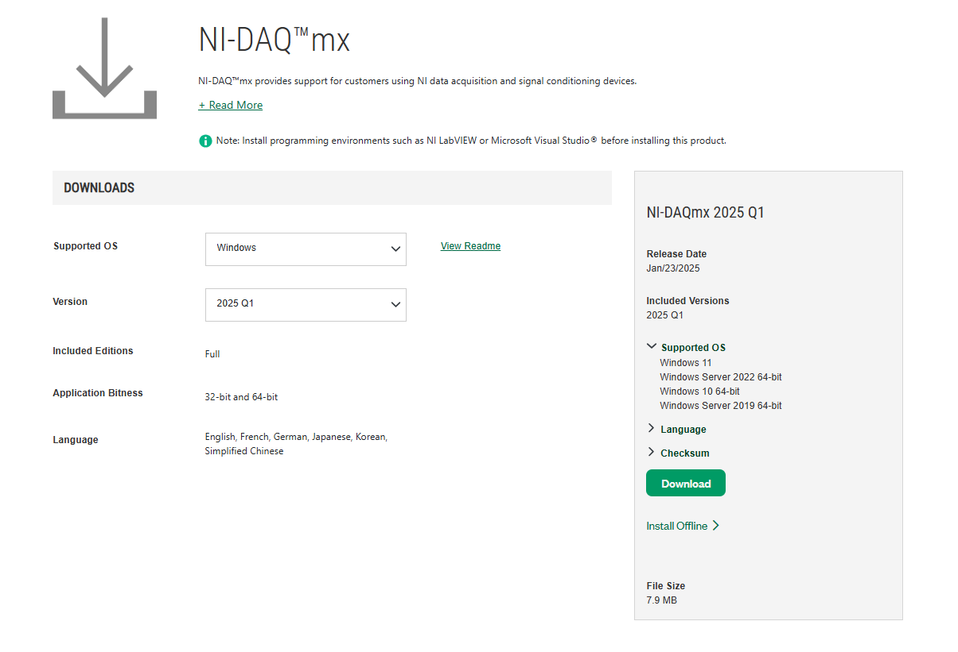

<https://www.ni.com/en/support/downloads/drivers/download.ni-daq-mx.html#559060>

**NOTE:** Using DAQ device without LabView is also possible using NI-ELVIS program (NI-ELVISmx), providing a few working modes (not needed in this application).

***DATA LOGGING STEPS***

The purpose of the preliminary work on given DC motor is to determine the relation between the input and output. The procedure should be followed as below;

* One of the Analog inputs of the DAQ device should be connected to position feedback sensor (encoder).
* The DC motor should be driven with a known input voltage and output position should be logged by constructing a related LabView program via DAQ device. The exact execution timing of the input voltage should be controlled as well.
* Input output relation should be logged by constructing a related LabView program via DAQ device.
* A connection schematics for DAQ device is given below.

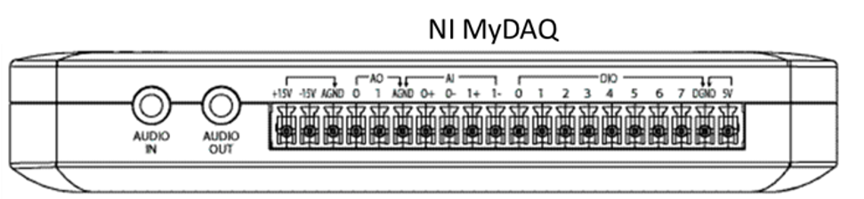

**Progressing Lab Works Questions during Control Design Procedure**

The purpose of the project is to have an overall experience in practical PID control on an armature controlled DC motor. While following the procedure to reach the ultimate goal, it is expected to have experience on system identification procedures, data processing, mathematical approaches and microcontroller application with control algorithms in practical way. Students should answer all questions and hand over progress reports on each specified due dates.

1. What is the purpose of the project that explained and details shared in the course?
2. Briefly describe the given physical system. Draw the system block diagram in your description.
3. What is the purpose of collecting data? What is the input and what is the output?
4. What equipment have been provided to you to collect data?

*Due to 27/03/2025 (W5)*

1. Explain the data collecting procedure. Which hardware and software have you used during the data collecting procedure? Reinforce your description by giving a screenshot on software.
2. Is the given system black box or gray box? Explain the reason briefly.
3. Which software tool did you use to determine the parameters of the transfer function? Explain briefly.
4. Explain why you have collected 5 different datasets. How many did you use to estimate parameters?

*Due to 10/04/2025 (W7)*

1. Plot the estimated angular velocity with respect to time for each different inputs.
2. Have you applied any filtering operation to data? Why? If so, plot all the filtered and raw data on a graph with respect to time. Comment on the graphical results.
3. According to the data you collected and estimated, what is the resultant transfer function of given system?
4. Why do we need validation? Explain your validation procedure and plot the related graphs.
5. Why haven’t you used the built-in encoder for the positional feedback? Explain.
6. Explain the potentiometer calibration procedure.

*Due to 08/05/2025 (W11)*

1. Design and simulate following requirements with specified controllers by using an appropriate simulation program and show the results clearly by using graphs.
   1. With P Controller, obtain the shortest rise time (fastest possible response).
   2. With PI Controller, cancel the steady state error with minimum overshoot.
   3. With PID Controller, obtain the fastest response without steady state error.
2. Apply each resultant controllers of the previous question to the real system and log and plot the real life system response. Compare the results. If you need further tuning, give details that clarifies your tuning approach and show all resultant response.

*Due to 22/05/2025 (W13)*

1. Share the generic code that includes the PID control algorithm. Explain each row as comments.
2. How did you log the results with the microcontroller that you have used? Explain.

*Due to 12/06/2025 (W16)*